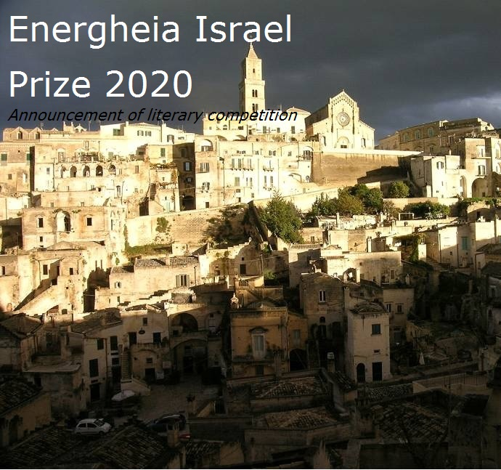
ENERGHEIA ISRAEL PRIZE 2020
The cultural association Energheia of Matera, with the patronage of Regional Administration of Basilicata, and in association with the Bezalel Academy of Arts & Design of Jerusalem, are proud to announce the literary Prize “Energheia Israel”.
Writers, who must be 20-30 years old, are allowed to participate to the competition with just one unpublished short story, written in English or French, on a freely chosen subject, of no more than seven pages (25 lines per page). The story must be sent, with the author’s name, age, address (tel. number and e.mail) before 15th May 2020 to:
oriash@013.net or drorpim@zahav.net.il

A committee appointed by the organizers will read and evaluate the stories in order to indicate the best five to be submitted to the jury’s final judgement.
The jury will declare the winner in July 2020. The winner will be invited to travel to Matera (Italy) for three days, all expenses paid, and take part in the final ceremony that will be held in September 2020.
It’s up for the organizers of the competition to decide about anything which is not included in the present regulations.
A copy of the present announcement can be asked to the same address indicate above.
Matera (Italy), January 2020.

